Manufacturing SOP: Face Visor Assembly
Author: John Loveluck Version 21 April 2020

Purpose
To define:
- Process for assembling Delve Face Visors
- Precautions to prevent spread of COVID-19 by contamination of face visors during manufacture and distribution
- Means of recording implementation of processes and precautions.

2. Scope
Qualified staff/volunteers manufacturing the Addenbrooke’s approved design of DELVE face visor at Makespace, Mill Lane, Cambridge.

3. Responsibilities
All:
- To ensure Makespace facility remains a “safe zone”, free of virus as far as possible
- Not to enter the Makespace facility if you show any symptoms that could indicate COVID-19, or you have been in recent contact with anyone showing symptoms.
- Report any symptoms that arise within 5 days of working in the Makespace facility to cei@addenbrookes.nhs.uk

Supervisor:
- Ensure process is conducted according to SOP
- Document & report any non-conformances

Technician:
- Conduct cleaning, assembly, packaging as described
- Wear PPE as required.

4. Hygiene Precautions

Entry to workspace & Designation of Areas
Preventing the virus entering the workspace area is a high priority.

- All personnel will first enter “Contamination not controlled” area
- On entry to this area, all personnel must remove outdoor clothing and store it in “Staff outer vestibule area”, NOT on the worktables
- All personnel must record time of entry and exit and sign a statement of general good health, stating duration of isolation and any potential opportunities for virus transmission - this will allow traceability in case of subsequent symptoms appearing
- Before entering the “Production Area”:
  - Use the “Prep Area” to wash hands thoroughly
  - Don PPE
- To transition back from the “Production Area” to “Dirty Goods In”
  - Use the “Prep Area” to doff PPE
- To enter or leave the “Contamination controlled”, you must observe the strict prohibition of the gangway.
- To protect operators, all workstations are disinfected daily
- All parts must be kept in a WIP box when they are not being directly worked on
- WIP boxes and parts must only be placed on the work surfaces labelled on the diagram
- The operator work stations mapped out (per the standardised work sheet below) have been positioned to allow a minimum of 2m clearance between operators to minimise operator cross-contamination risks.

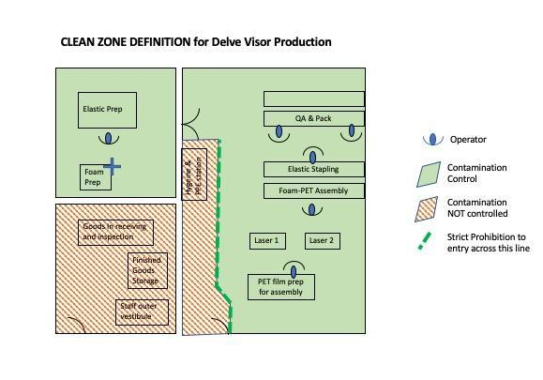

Personal Protective Equipment (PPE)
The intent of PPE in this context is to prevent virus from assembly staff contaminating the visors in production. This is important, since asymptomatic individuals can spread the virus through touch and respiration.

The following are to be worn while handling all parts:

- Disposable gloves - replace if removed
- Face masks - paper or fabric masks should be sufficient for this risk. Vented masks should have the valve sealed closed so exhaling is also filtered

5. Equipment & Materials

Equipment
- Laser cutters x 2
- Bandsaw
- Scissors
- Stapler
- Foam-to-visor assembly jig (3-off built, of which two commissioned)

BoM Materials
- PET sheet or roll 0.20mm thick, sheet: 700 x 1000mm, makes 8 visors, Roll: 560mm wide, makes 2 visors per setup
- Latex free elastic, 25mm width, length 345mm
- Open cell Polyurethane foam sheet, 230mm x 28mm self-adhesive backing (1000 x 2000mm makes 320 visors with 10% waste)
- 26/6 Staples (2-off per shield)
- 2 labels: producer and batch details Avery L4731
- Clean PP bag 300mm x 400mm

Packaging BoM materials
- Shipping Carton 300 x 400 x 350mm (Manufacturer: Sutton, source: Linx)
- 3” packing tape, Brown, 1000mm per Carton
- Labels 99mm x 67.5mm for carton ID and postponed use-after date (1-off per nominal case)
- Instructions for Use

Consumables in production
- Permanent Pens labels for labelling WIP boxes
- A5 paper sheets for WIP Product labels
- 35L and 24L Really Useful Boxes for WIP
- Face masks, disposable or washable - sufficient for 1 mask per Technician per shift
- Disposable latex-free gloves - sufficient for 3 pairs per Technician per shift
- Cleaning cloths for all work surfaces
- Broom to remove production waste (eg dropped materials, release film from foam)
- Soap and hand gel for hand washing
- Paper towel for hand washing
- IPA solution for cleaning laser cut visors
- Approved cleaning solution
- Anti mist spray for cleaning inside visors
- Soft roll tissue for visor cleaning

6. Preparation of work areas and incoming goods

6.1 Cleaning work surfaces and equipment

Work surfaces and equipment must be cleaned before each work session using routine cleaning and disinfection procedures (e.g., use cleaners and water to pre-clean surfaces then apply an EPA-registered, hospital-grade disinfectant). https://www.epa.gov/pesticide-registration/list-n-disinfectants-use-against-sars-cov-2
The process for cleaning the space is as follows:
- Place cleaning materials on ‘Dirty Goods In’ work table
- Enter ‘Hygiene and PPE’ area via the marked out gangway only
- Wash hands for 20 seconds, put on PPE in following order:
  - Face mask
  - Latex non-sterile gloves
- Clean all work surfaces first with regular cleaning agents, followed by disinfectant
- Clean all tools with appropriate cleaning wipes, then set them out in correct location as indication by the Production Layout Diagram
- Return to the ‘Prep Area’ and:
  - Remove gloves, place in bin
  - Remove mask, place in bin

The area should be cleaned at the start of each work day, or if there is reason to believe the cleanliness of the space may have been compromised (e.g. entry of personnel not wearing correct PPE).

6.2 Goods receiving
Incoming goods should be logged and stored, but not completely unpackaged, in the “Incoming Goods” area.

Since viruses may remain viable for several days on surfaces, there is a risk that materials being brought into Makespace have been contaminated during distribution. Therefore, outer layers of packaging should be removed wherever possible before bringing materials into the production area.

If the product has not come in appropriate packaging, then it should be cleaned using a clean cloth and appropriate EPA approved disinfectant solution. In the case of elastic, it is appropriate to clean this on a hot wash in the washing machine.

Ensure that ‘clean’ goods are placed immediately onto a ‘clean’ table in the ‘Production Area’.

The receipt of goods is traced by the batch history Gsheet, which records the date stamp, operator identification and assigns a unique transaction serial number to the activity. This is transcribed onto an A5 card initiated by the operator.

7.Manufacturing process steps
The overall process is as in the diagram below.

Elastic straps and foam will be prepared in intermediate quantities before production. The Visors are then assembled in batches, target batch quantity is 24 (carton quantity).

A Batch Record is made electronically as work flows, and is mirrored by A5 travelers added at each step. Traceability will allow us to decide what action to take in the event of an individual displaying symptoms shortly after assembly.

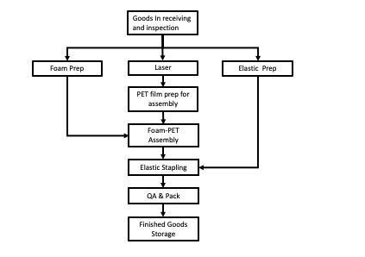
With the exception of Goods In Receiving and Inspection, Laser and Finished Goods Storage, there is a detailed single point lesson for each task describing the activity, quality outcomes and task-specific safety precautions.

Material should flow around the workspace as follows:

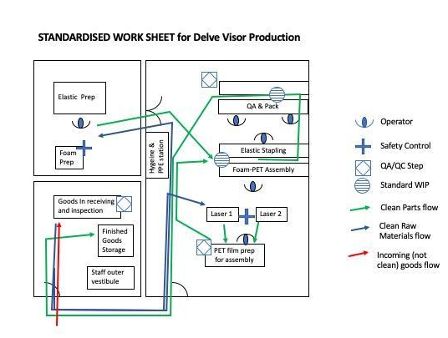

QA and Pack

- Quality Control:
  - Reject visors with scratches greater than 1cm in length in line of sight
  - Reject visors with the foam/elastic attached to the bottom of the visor
  - Reject visors with less than 2 staples
  - Reject if poor adhesion between visor and foam
  - Reject if excessively bowed, indicating elastic is too short
  - Any part of the PPE that is liable to come into contact with the user when the PPE is worn must be free of rough surfaces, sharp edges, sharp points and the like which could cause irritation or injuries:
    - Reject visors with defects on the outer edge that may scratch and damage skin
    - Reject visors where the staples have closed improperly forming a hazard which could cause minor injury such as scratches to hand/face

8. Product Identification / Labelling
The visor is labelled directly with two labels, one to identify the producer and one to record its batch. They are:
Visor Product Label 1of2 v1.docx
Visor Product Label 2of2 v1.docx
The carton is identified with a single label, to be affixed to either of its minor vertical faces. This is:
Visor Carton Label 1of2.docx
If a risk of non-compliance to this SOP is identified in finished goods, a further label to quarantine and defer use of the visors before a defined date. This label should be immediately adjacent to the single carton label. This is
Visor Carton Label 2of2 v1.docx
The requirements of labelling, with examples, are in the additional document “Label Content”.

9.Supporting Documents
- Single Point Lesson for Visor Mfr v1.pptx

10.Change History

Version | Changes since previous version | Date / approver
1 | Not applicable, first issue | 30 March 2020 / Abi Bush
2 | Finalisation of manufacturing process steps and packaging specification | 01 April 2020 / Nick Scott

Face Visor Batch Record
To be completed for each batch of Visor assemblies

Batch Number (FV-20mmdd-n) | Date started
FV-20

Material |  | Initials | Comments
PET batch
Elastic Strap Batch
Brow Foam Batch

Process Step | Initials | Date/Time | Comments
PPE worn as required
Laser cut PET |  |  | Number of face shields cut:
Assembly
Clean
Pack
Inspect |  |  | No. assemblies from batch
Box
Observations (including any rejects/problems arising)

